Design Detail

Detailed Parts
Figaro 2444 sensor
The Figaro 2444 ammonia sensor has several ideal features. It has low power consumption, high sensitivity and selectivity to ammonia, and a miniature size. The sensor utilizes a multilayer sensor structure. There is a glass layer for insulation between a ruthenium oxide heater and alumina substrate. A pair of gold electrodes for the heater is formed on a thermal insulator. The gas sensing layer, which is comprised of tin dioxide, is printed on an electrical insulation layer which covers the heater. A pair of gold electrodes for measuring sensor resistance is formed on the electrical insulator. Finally, activated charcoal is filled between the internal and the outer cover to reduce the influence of noise gases. In the presence of ammonia, the sensor's conductivity increases depending on the gas concentration in the air. A pulsed electrical circuit operating on a one second circuit voltage cycle can convert the change in conductivity to an output signal which corresponds to gas concentration. The sensor is housed in a chamber which includes a safety valve on the very end. This feature allows relief in case of overpressure by excessive mass transfer of moisture and other contaminants through the transducer protector.

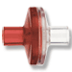
Transducer protector
The transducer protector is simply a layer of hydrophobic membrane (Goretex), which deters mass transfer of liquids across the membrane. Liquids are harmful to electrical equipment, thus they should be kept out of the sensor chamber at all costs.

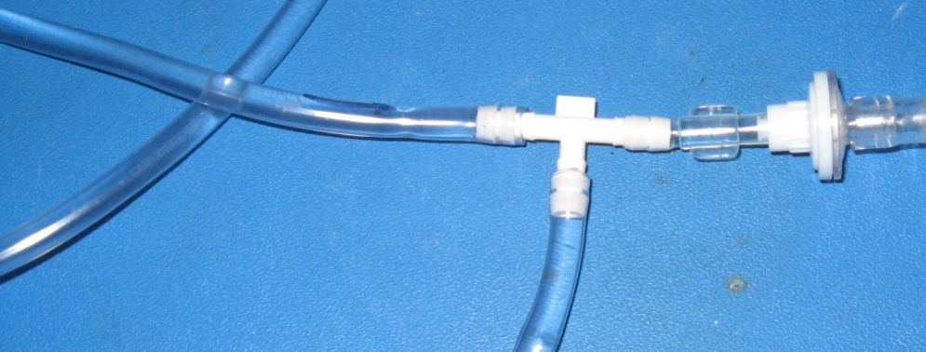
Dialysis tubing

Finally, the dialysate tubing in the figure above serves to indicate the point at which the entire sensor component integrates into the dialysis machines.

Materials Used
- Sensors
  - Indicator-based sensor
  - Figaro 826 sensor
  - Figaro 2444 sensor
- Testing
  - Electrical wires
  - Power supply
  - Ammonium chloride
  - Water
  - Sensor chamber
  - Goretex membrane
  - Tubing (T-junction)

User Interface
The user interface for this sensor will be integrated into the user interface for the entire dialysis machine.

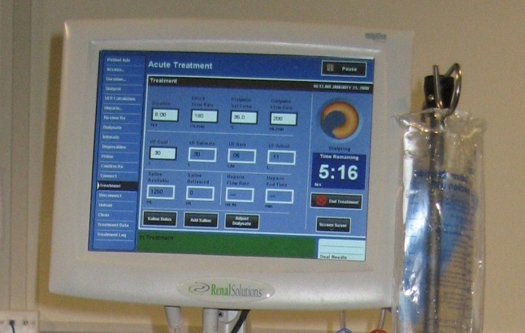
Computer monitor as user interface
The concentration of ammonia in the dialysis fluid will be displayed on the monitor at all times during the dialysis process. If at any time, the ammonia concentration reaches its prescribed maximum, the screen will blink red, and an audio alarm will sound. This warns the patient or the nurse to terminate the dialysis process immediately. The monitor will also serve as the calibration interface for the sensor. It will guide the user through the simple installation and calibration of the sensor to prepare it for immediate use.

