Engineering Models

Mass Transfer
Goretex is a porous form of polytetraflouroehtylene formed in such a way to generate a highly porous network of fibers capable of allowing the diffusion of water vapor and gases while halting liquid flow. In both the old sensor system and the new proposed design, the membrane and the sensing chamber form a physical system known as pervaporation, or the separation species via partial vaporization through porous membranes. Industrial applications use pervaporation to separate flow streams with very different partial pressures or through the use of selective membranes. When applied to our proposed sensor, we modeled the dialysis flow out of the Sorbent cartridge as the mixed flow stream. The Goretex membrane allows the ammonia to flow into the sensing chamber.
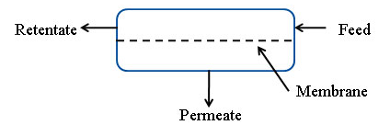
Diagram of a pervaporation system

We can model the system using the following equation:

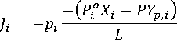
Mass transfer equation for pervaporation system
Where:
J_{i} = Molar flux across membrane.
p_{i} = permeability coefficient of species i
P_{i}º = Saturation pressure of pure component I at feed temperature
X_{r,I} = Mole fraction of component i in liquid feed
P = Pressure
Y_{p,I} = Mole fraction of species I in permeate
L = membrane thickness

The main information needed to perform this calculation is p_{i}. This value portrays the specific behavior of a molecule as it moves through the membrane. Unfortunately, there is little information regarding the movement of ammonia through a Goretex. We investigated a number of experiments to characterize different measures of ammonia interaction with the membrane. We discovered that the mass transport coefficient of SO₂ (a larger molecule than ammonia) is between 0.8 and 1.5 cm/s, which is a very high number. Another alternative approach is examining the physical properties of Goretex like the void fraction and the percentage of surface area covered by pores.

Henry’s Law
Our proposed ammonia sensor does not directly measure the level of solute dissolved in the dialysate flow stream. Instead, it measures the concentration of ammonia diffused through the membrane and employs Henry’s Law to determine the given concentration of ammonia in the liquid. Henry’s law states that:

At constant temperature and equilibrium conditions, the amount of gas dissolved in a liquid is directly proportional to the partial pressure of gas above the liquid.

Henry’s Law generally takes the form:
$p=k⋅c$
Henry's Law formula
Where:
p = partial pressure of solute above the solution.
c = concentration of solute in the solution
k = Henry’s Law Constant

In particular, Henry’s Law is particularly applicable for low concentrations of solute in non-idea two-species solutions. The FDA regulation for ammonia in dialysate is only 20 ppm in thirty minutes. Room temperature and pressure are not a good approximation of the ideal gas solution. Further study needs to be conducted into whether other ions and chemicals used to balance blood chemistry interfere with our analysis.

Engineering Modeling and Optimization
- Objective
  - Maximize the amount of ammonia gas flowing through Goretex membrane
- Dependent components responsible for achieving this objective
  - Flow rate of spent dialysate
  - Mass transfer coefficient of membrane
  - Sensor chamber design
- Quantitative metric to gauge this objective
  - Mass flux of ammonia gas through membrane
- Design parameters associated with dependent components
  - Membrane area
  - Solute diffusion coefficient
  - Initial and final concentration of ammonia
- Physical principles that relate the objective function to design parameters
  - Mass transport
- Algebraic equation and theory
  - Maximize the amount of ammonia gas flowing through Goretex membrane
According to Fick’s first law, the flux is:
$$\begin{aligned}N_{z}=−D_{\text{AB}}\frac{\text{dC}}{\text{dz}} \\ N_{z}=\frac{D_{\text{AB}}\left(C_{1}−C_{2}\right)}{l}\end{aligned}$$
Fick's law of diffusion
Using the boundary conditions:
$\begin{aligned}z=0 \\ z=l\end{aligned}$ $\begin{aligned}C=C_{1} \\ C=C_{2}\end{aligned}$
Where N_{z} is the flux and D_{AB} is the binary diffusion coefficient

Flux through a porous membrane can be obtained by summing over all pores. The accuracy of this method depends on the particular model used and the actual structure of the membrane pores. Inaccuracies often arise because, as shown in the figure below, pore length is often greater than the thickness of the membrane, and the cross-sectional area of each pore is not identical.

Pores in membrane
The membrane flux of the solute is related to total flux by the following equation:
$$J_{z}=\frac{ε}{τ}N_{z}$$
Membrane flux
Where ε is the volume fraction of pores in the membrane and τ is the tortuosity (accounts for the fact that the pores are not straight but rather intersect and are oriented at more or less random directions).

Combining the above equations give:
$$J_{z}=\frac{ε⋅D_{\text{AB}}}{τ⋅l}\left(C_{1}−C_{2}\right)$$
The parameters in the beginning can be lumped and referred to as the membrane coefficient:
$$β=\frac{τ⋅l}{ε}$$
Definition of membrane coefficient

A more rigorous analysis includes resistance by the liquid phase adjacent to the face of the membrane. The flux across the liquid film adjacent to the membrane is:
$$J_{z}=k_{1}\left(C_{1b}−C_{1}\right)$$

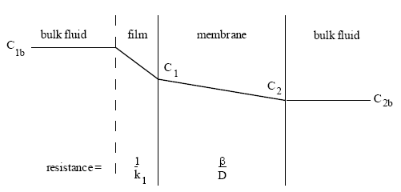
Film and membrane resistance
Combining all previous equations gives an overall value for mass transfer:
$$\begin{aligned}J_{z}=K\left(C_{1b}−C_{2b}\right) \\ \frac{1}{K}=\frac{1}{k_{1}}+\frac{β}{D_{\text{AB}}} \\ f(β)=J_{z}={\left(\frac{1}{k_{1}}+\frac{β}{D_{\text{AB}}}\right)}^{−1}\left(C_{1b}−C_{2b}\right)\end{aligned}$$
Overall mass transfer equation

To simplify the problem, the film resistance is assumed to be negligible. The above shows mass transfer for any one component through a membrane. For this model, there are two competing components for transfer across the membrane. As the pore size of the membrane increases, the mass flux of ammonia increases. However, this also increases the amount of moisture that flows across the membrane, which is a contaminant. Therefore, we would like to maximize the ammonia gas transfer across the membrane by minimizing the effect of moisture contamination. The objective function would be the sum of an increasing function (mass flux of ammonia) and a decreasing function (lack of moisture contamination).

$$J_{\text{NH}3}={\left(\frac{β}{D_{\text{NA}}}\right)}^{−1}\left(C_{1\text{NH}3}−C_{2\text{NH}3}\right)$$
Mass flux of ammonia
$$J_{W}=\left(\frac{β}{D_{\text{WA}}}\right){\left(C_{1W}−C_{2W}\right)}^{−1}$$
"Lack of" as 1/moisture flux

Summing the two equations gives our objective function:
$$J={\left(\frac{β}{D_{\text{NA}}}\right)}^{−1}\left(C_{1\text{NH}3}−C_{2\text{NH}3}\right)+\left(\frac{β}{D_{\text{NA}}}\right){\left(C_{1W}−C_{2W}\right)}^{−1}$$
Objective function for optimization

- Constraints on objective and parameters
  - Concentration of ammonia
    - Initial: 0.2 kg/m³
    - Final: 0 kg/m³
  - Concentration of water
    - Initial: 0.044 kg/m³
    - Final: 0 kg/m³
  - Difficusion coefficient
    - Ammonia: 2.77 x 10⁻⁵ m²/s
    - Water: 2.85 x 10⁻⁵ m²/s
  - Temperature
    - T = 37°C
  - Membrane specifications
    - 0 < β< 10⁻⁵ m
Calculations of the above parameters are shown as follows:
Calculate the concentration of water in the vapor phase in the dialysate
Assume water is ideal gas:

Calculate the concentration of ammonia in vapor phase in dialysate
Diffusion coefficient of water in air:

Using the solver in excel:
Parameters and constraints for optimization
Parameters/Constraints
β_low | 1.00E-20
β_high | 1.00E-05
D_{w} | 2.77E-05
D_{n} | 2.85E-05
ΔC_{w} | 0.044
ΔC_{n} | 0.2

index | b (m) | J (kg/s-m²)
0 | 1.00E-06 | 6.52048
1 | 2.00E-06 | 4.49096
2 | 3.00E-06 | 4.36144
3 | 4.00E-06 | 4.70692
4 | 5.00E-06 | 5.2424
5 | 6.00E-06 | 5.87287
6 | 7.00E-06 | 6.55764
7 | 8.00E-06 | 7.27633
8 | 9.00E-06 | 8.01765
9 | 1.00E-05 | 8.77479
10 | 1.10E-05 | 9.54345

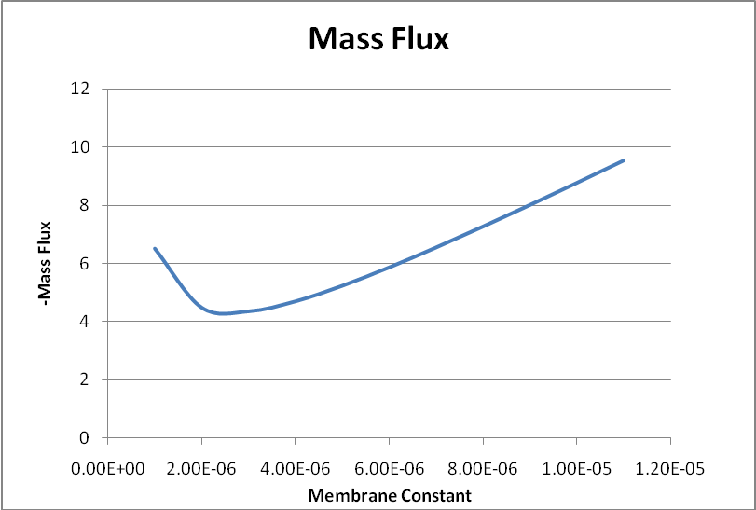
Mass flux of moisture contamination as a function of membrane constant

Calculating the optimal membrane constant
index | β (m) | J (kg/s-m²)
0 | 1.00E-06 | 6.52
1 | 2.00E-06 | 4.50
2 | 3.00E-06 | 4.36
3 | 4.00E-06 | 4.71
4 | 5.00E-06 | 5.24
5 | 6.00E-06 | 5.87
6 | 7.00E-06 | 6.56
7 | 8.00E-06 | 7.28
8 | 9.00E-06 | 8.02
9 | 1.00E-05 | 8.77
10 | 1.10E-05 | 9.54
b_opt | 2.64E-06 | 4.33

The optimal membrane constant is 2.64E-06 m, or 2.64 μm.

According to literature, a typical membrane constant value is on the order of 10⁻⁵m; therefore the calculated optimal membrane constant lies within the correct range. However, the experiment discussed in this paper refers to large molecules such as caffeine. Our molecules are relatively small, water and ammonia. Therefore, the membrane constant does not need to be as large.

Electrical Engineering
The electrical sensor detects the amount of ammonia gas within the dialysate. The sensor is composed of semi-conductive materials which react with the ammonia gas. This reaction changes the internal resistance of the sensor and increases its conductivity. The ratio between the internal resistance and the reference resistance correlates to the ammonia concentration present.

The experimental setup includes using a DC and AC voltage power supply, connected in series to the sensor, and a load resistor. By measuring the voltage across the load resistance and using Kirchhoff’s voltage law, the voltage and conductivity of the sensor are determined. Using this knowledge the internal resistance and thus the amount of ammonia in the medium can be found. For data logging purposes a LabView script is used for accurate measurements of the voltage. A conductive thermometer is used for temperature readings.

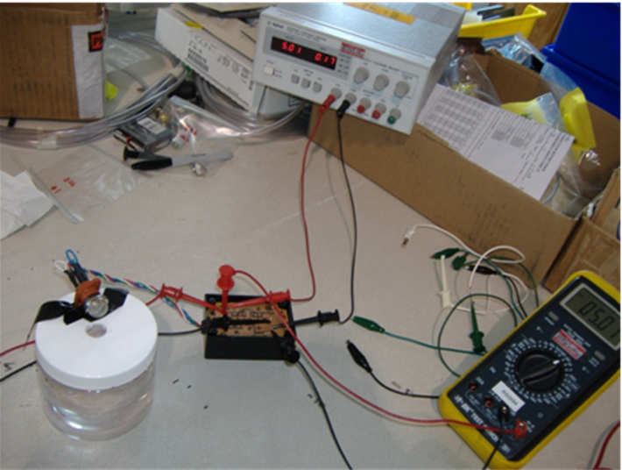
Sensor experimental setup
Future work involves determining voltage of the load resistor, which corresponds to the ammonia concentration of 20ppm, creating the interface between the existing dialysis apparatus and the sensor, and the indication device when the ammonia concentration in the dialysate reaches 20ppm. In addition it will be better to use a coupler device which converts temperature readings into a voltage, for more accurate temperature measurements.

