Experimental Data

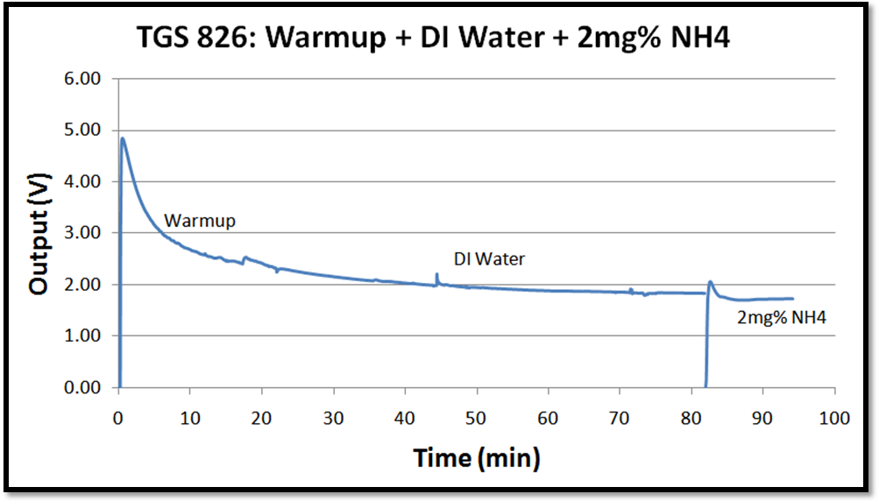
TGS 826 in simple housing without transducer protector; full test with warm-up, DI water, and ammonia

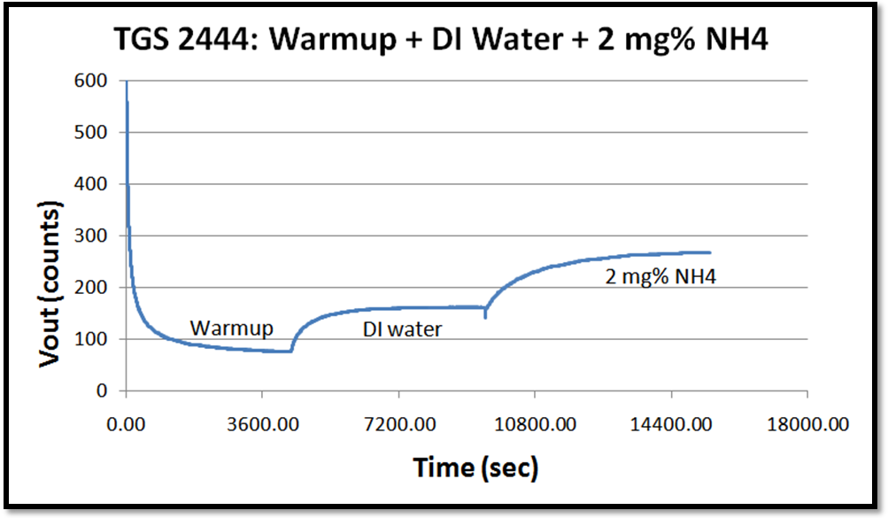
TGS 2444 with transducer protector, full test with warm-up, DI water, and ammonia

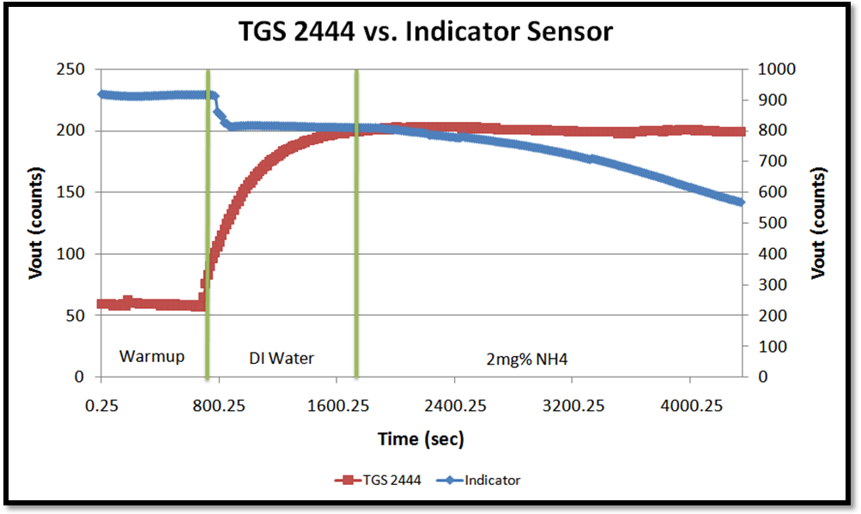
TGS 2444 and indicator sensor in same dialysis tubing setup

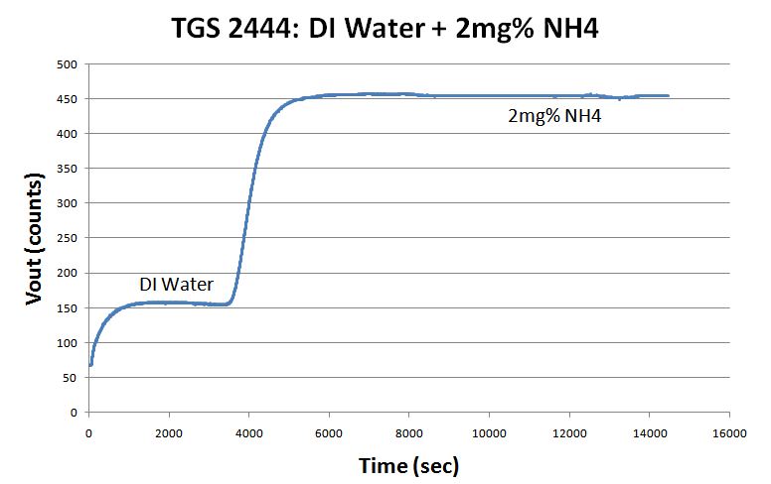
TGS 2444 using plastic housing from existing disposable and Goretex membrane

