Hemoglobin (protein) Functions and Mechanisms
A quaternary protein structure is defined as the clustering of several individual peptide or protein chains into a final specific shape. There is a variety of bonding interactions such as hydrogen bonding and disulfide bonds. The two main types of quaternary protein structure are fibrous and globular. Each molecule of hemoglobin contains four peptide chains, two α-chains and two β-chains, in which is known as a tetramer. Figure-2 below depicts a hemoglobin molecule.

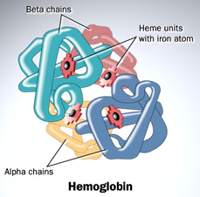
Figure-2: Hemoglobin

Since the main function of hemoglobin is to transport oxygen, it is important to understand the binding processes. The primary factor that determines how much oxygen is bound to hemoglobin depends on the partial pressure of oxygen, or pO₂ in the hemoglobin solution. There are a total of four binding sites in each hemoglobin, and when all sites are bound with oxygen, this molecule is known to be 100% saturated and cannot carry any additional oxygen molecules. As pO₂ increase, the saturation percentage also rises. Figure-3 shows the relationship between pO₂ and saturation percentage. Oxygen binding at the four heme sites does not occur simultaneously. As the first oxygen molecule binds to a heme group, a conformational change is introduced to the protein chain. These changes nudge the neighboring chains into different shapes, causing them to bind oxygen more easily. As a result, it is more difficult to bind the first molecule, but binding of the second, third, and fourth oxygen molecule becomes progressively easier. When releasing oxygen molecules, on the other hand, as soon as the first oxygen molecule drops off, the protein changes shape, in which promotes the remaining three oxygen molecules to be quickly released.

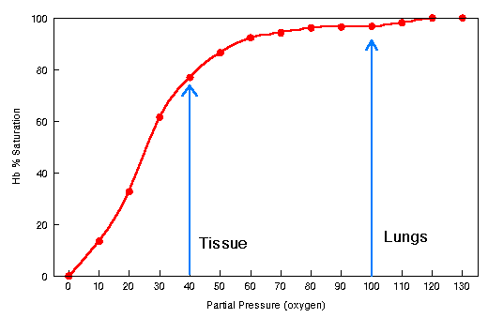
Figure-3: Hemoglobin Saturation Curve

The processes of oxygen binding and releasing are primarily based on oxygen concentration. The function of hemoglobin as an oxygen carrier is fundamentally linked to the equilibrium between the two main states of the quaternary structure, T (tensed) and R (relaxed). In the T-state, the unliganded form contains extra stabilizing interactions between subunits while the R-state contains high affinity interactions that oppose oxygen binding to stabilize the tetramer structure. These structural changes result in different important functional properties such as cooperativity of oxygen binding and allosteric control by pH and anions.

In the tensed state, the Fe ion is becomes less accessible for oxygen to bind it, as it is pulled out of the plane of the porphyrin ring. In the relaxed state, the Fe atom returns back to the plane of the porphyrin ring and therefore becomes more accessible to bind oxygen, as a result increasing oxygen affinity. The transformation from tensed to relaxed state occurs when oxygen binds to the tensed state under high oxygen pressure environment in the lungs. Likewise, the transformation from relaxed to tensed state occurs when oxygen is released under low oxygen pressure environment in the tissues. Low oxygen environment causes the dimers to rotate back and shift the Fe atom to a conformation where it becomes less accessible to oxygen.

In the T structure, the iron ion is pulled out of the plane of the porphyrin ring and becomes less accessible for oxygen to bind to it, thus reducing its affinity to oxygen. In the R structure the iron atom is in the plane of the porphyrin ring and is accessible to bind oxygen, thus increasing its oxygen affinity (Keates, 2004). The transformation from the T to R structure occurs when oxygen binds to the T structure under the high oxygen pressure environment in the lungs, which causes the rotation of the two dimers and shifts the remain iron atoms so that they become more accessible to oxygen. Likewise, the transformation from the R to T structure occurs when oxygen is released under the low oxygen pressure environment of the tissues which causes the dimers to rotate back and shifts the iron atoms so that they become less accessible to oxygen (Keates, 2004).

