Respirocytes and Erythrocytes
—————————
Digital Object Identifier inserted by IEEE

Denise Hsu
Email: denise@motusinmotus.com
Website: www.motusinmotus.com

Abstract—Red blood cells, or erythrocytes, are the most common type of blood cells. Their main function is to deliver oxygen from the lungs or gills to tissues in the body. Blood transfusion is the process of transferring blood-based products from one person to another person’s circulatory system. Blood banks must maintain a certain amount of blood supply for emergency and daily use. The most common way for maintaining blood supply is from blood drives where donors donate blood. Due to the low levels of blood supply, synthetic blood research is developed to find alternative ways to support blood transfusion. Respirocytes have been proposed as alternatives for red blood cells with the same functions. However, it is still entirely theoretical due to the fact that functions of natural hemoglobin are difficult to mimic. Some considerations to improve respirocytes include biocompatibility, size, geometry, amount of oxygen delivered, binding and releasing of oxygen atoms, selective gas transport, and possibility of foreign object rejection. To successfully mimic red blood cells, not only should respirocytes have the same functions as erythrocytes, the body must also accept it as part of the host..

Index Terms—Respirocytes, erythrocytes, erythropoietin (EPO), myoglobin, hemoglobin, oxyhemoglobin, deoxyhemoglobin, quaternary protein, glycophorins, heme group, transport protein, erythropoiesis, tensed/relaxed states, homeostasis, anemia, red blood cells, white blood cells, plasma, platelets, nanotechnology, allosteric protein, ligand, integral protein, peptide bond, disulfide bond, α-chains, β-chains, porphyrin ring, rotor, Embden-Meyerhof, ideal gas law, diffusion

Introduction
The circulatory system is made of blood vessels and muscles that control blood flow throughout the body. The main components include heart, arteries, capillaries, and vein, with blood as the circulating fluid. As circulation occurs, blood is pumped from the heart and travels from the left ventricle of the heart into the aorta. Blood in the aorta, enriched with oxygen, is then delivered from arteries to tissues and muscles throughout the body, meanwhile releasing oxygen molecules in exchange for carbon dioxide in the capillaries of tissues and muscles. Blood ultimately returns to the vein and back to the heart with low levels of oxygen and high levels of carbon dioxide, which is exhaled from the lungs.
Blood consists of red blood cells, white blood cells, and platelets floating in a liquid called plasma. Each of the components have specific functions. Red blood cells are responsible for oxygen binding and releasing at different sites, white blood cells engulf foreign molecules including bacteria, and platelets are responsible for blood clots at in open wound to prevent extra blood loss. The plasma component is composed of 95% water and 5% dissolved substances such as salt. An average adult has 5 liters of blood circulating the body, with each drop of blood (~0.06mL) containing 5 million red blood cells, 8,000 white blood cells, and 250,000 platelets.
Erythrocytes can be further investigated to properly understand and mimic its functions. When designing respirocytes, or miniature micro-robots that mimic red blood cell functions, the geometry and dimensions should be similar. The geometry of an erythrocyte consists of a disc-like shape with a diameter of 7 μm and thickness of 2.5 μm, with a dimple at the center of the disc on both sides, as shown in figure below.
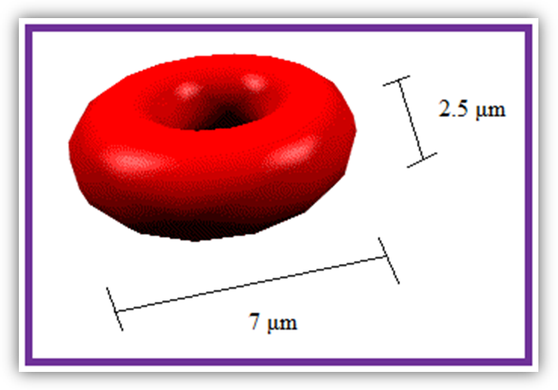
Figure 1: Geometry and dimensions of a red blood cell

Erythrocytes mainly consists of hemoglobin, or a quaternary protein structure containing heme groups with iron atoms that temporarily link to oxygen molecules and release them throughout the body. Hemoglobin also links to waste products such as carbon dioxide, which are released from the body through exhale of the lungs. A typical erythrocyte contains about 270 million hemoglobin molecules, with each molecule carrying four heme groups.

To calculate the number of oxygen molecules carried by one red blood cell:

270,000,000 x 4 = 1,080,000,000 O₂ molecules

If 1 drop of blood has a volume of 0.06 mL and contains 5 million red blood cells:
5,000,000 x 1,080,000,000
= 5.4 x 10¹⁵ O₂ molecules per drop of blood

Assuming that 85% of total blood volume in the body is enriched with oxygen molecules:
$\frac{4\text{.}0L}{0\text{.}\text{06}×{\text{10}}^{−3}L/{\text{drop}}}$= 66,667 drops of blood
$$\text{66},\text{667}\text{drops}×\left(5\text{.}4×{\text{10}}^{\text{15}}{\text{molecules}}/{\text{drop}}\right)$$
= 3.60 x 10²⁰ molecules of oxygen

If 1 mole of O₂ weighs 32.0 grams:
$${\left(3\text{.}\text{60}×{\text{10}}^{\text{20}}\text{molecules}\right)}/{\left(6\text{.}\text{023}×{\text{10}}^{\text{23}}{\text{molecules}}/{\text{mol}}\right)}$$
= 5.977 x 10⁻⁴ mole of O₂
$${\left(5\text{.}\text{977}×{\text{10}}^{−4}\text{mole}\right)}/{\left(1{\text{mol}}/{\text{32}}\text{.}0g\right)}$$
= 0.0191 grams of O₂

Red blood cells also consist of surface proteins, mainly glycophorins and band 3. Glycophorin is a membrane-spanning protein that carries sugar molecules. An example of glycophorins is glycophorin C, or an integral membrane protein that acts as the receptor for erythrocyte binding proteins. Band 3, on the other hand, is an anion exchanger, or transport protein responsible for mediating electroneutral charge of chloride for bicarbonate across a plasma membrane. However, of all the proteins from a red blood cell, hemoglobin is the critical component for oxygen and carbon dioxide delivery, and it is also the most difficult protein to mimic.

Hemoglobin

Basic Facts
Hemoglobin is found in red blood cells. There are two forms of hemoglobin: oxyhemoglobin and deoxyhemoglobin. Oxyhemoglobin is saturated with oxygen and has a higher affinity for oxygen than deoxyhemoglobin, which has a higher affinity for carbon dioxide. This increases the binding of oxygen to oxyhemoglobin, which transports oxygen molecules from lungs to tissues in the body via blood streams. The oxygen molecules are then released to myoglobin, which transports them to mitochondria for aerobic respiration. Deoxyhemoglobin, on the other hand, picks up two molecules of CO₂ along with two protons and released CO₂ in lungs where they are exhaled to the external environment.
Hemoglobin consists of a heme group wrapped within a quaternary protein structure. The heme group has a molecular weight of 616.48 atomic mass units with a chemical formula C₃₄H₃₂FeN₄O₄. It is also the color furnishing component of hemoglobin.
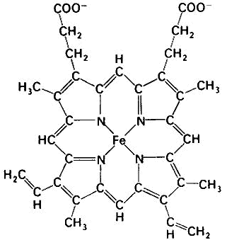
Figure 2: Heme group (Fe-protoporphyrin IX)

Structure
A quaternary protein structure is defined as the clustering of several individual peptide or protein chains into a final specific shape. There is a variety of bonding interactions such as hydrogen bonding and disulfide bonds. The two main types of quaternary protein structure are fibrous and globular. Each molecule of hemoglobin contains four peptide chains, two α-chains and two β-chains, in which is known as a tetramer.
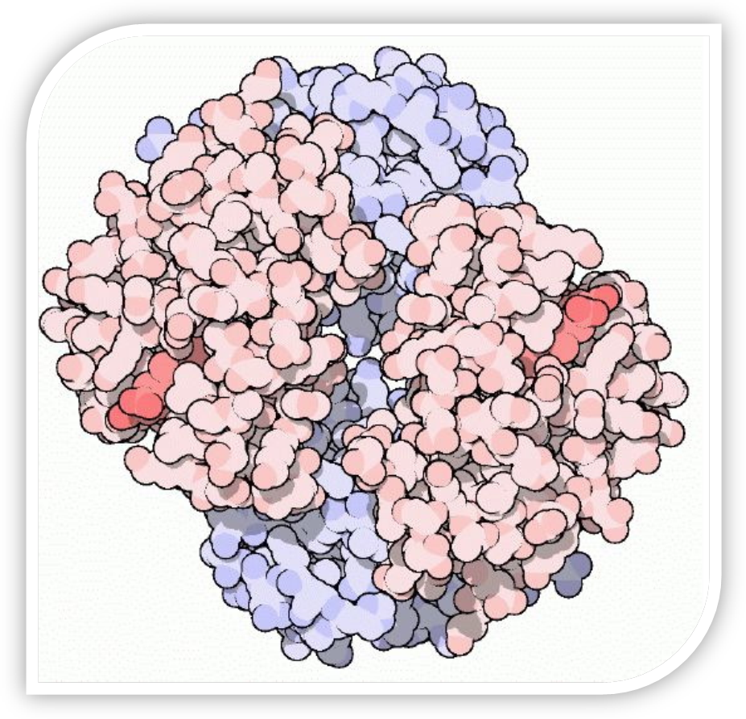
Figure 3: Hemoglobin

Function
Since the main function of hemoglobin is to transport oxygen, it is important to understand the binding processes. The primary factor that determines how much oxygen is bound to hemoglobin depends on the partial pressure of oxygen, or pO₂ in the hemoglobin solution. There are a total of four binding sites in each hemoglobin, and when all sites are bound with oxygen, this molecule is known to be 100% saturated and cannot carry any additional oxygen molecules. As pO₂ increase, the saturation percentage also rises. Figure-3 shows the relationship between pO₂ and saturation percentage. Oxygen binding at the four heme sites does not occur simultaneously. As the first oxygen molecule binds to a heme group, a conformational change is introduced to the protein chain. These changes nudge the neighboring chains into different shapes, causing them to bind oxygen more easily. As a result, it is more difficult to bind the first molecule, but binding of the second, third, and fourth oxygen molecule becomes progressively easier. When releasing oxygen molecules, on the other hand, as soon as the first oxygen molecule drops off, the protein changes shape, promoting the remaining three oxygen molecules to be quickly released.
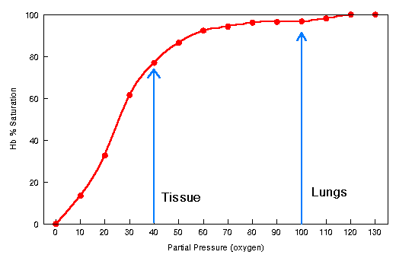
Figure 4: Hemoglobin saturation curve

Subunit rotation
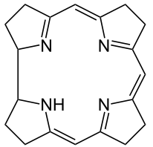
The processes of oxygen binding and releasing are primarily based on oxygen concentration. The function of hemoglobin as an oxygen carrier is fundamentally linked to the equilibrium between the two main states of the quaternary structure, T (tensed) and R (relaxed). In the T-state, the unliganded form contains extra stabilizing interactions between subunits while the R-state contains high affinity interactions that oppose oxygen binding to stabilize the tetramer structure. These structural changes result in different important functional properties such as cooperativity of oxygen binding and allosteric control by pH and anions. The change between the T and R states is due to rotation between the two alpha-beta dimers.
In the tensed state, the Fe ion is becomes less accessible for oxygen binding, as it is pulled out of the plane of the porphyrin ring. In the relaxed state, the Fe atom returns back to the plane of the porphyrin ring and therefore becomes more accessible to bind oxygen, as a result increasing oxygen affinity. The transformation from tensed to relaxed state occurs when oxygen binds to the tensed state under high oxygen pressure environment in the lungs. Likewise, the transformation from relaxed to tensed state occurs when oxygen is released under low oxygen pressure environment in the tissues. Low oxygen environment causes the dimers to rotate back and shift the Fe atom to a conformation where it becomes less accessible to oxygen.
Figure 5: Structure of a porphyrin ring in Hb
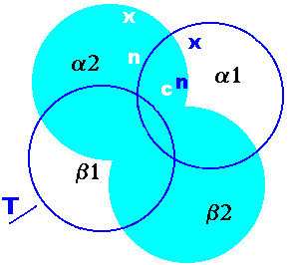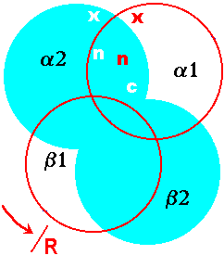
Figure 6: Tensed and relaxed states of hemoglobin

Respirocytes
Blood transfusion has saved countless lives, however, the need for matching blood type, short blood shelf life, and possible contamination are still major concerns of blood transfusion. Blood transfusion is needed when a patient experiences severe blood loss, such as during or after an operation or a major accident. It is also used to treat cancer patients and severe anemia. An understanding of blood function based on the biochemistry and molecule structures has prompted a search for blood substitutes.
To investigate the life cycle of a erythrocyte, it is critical to know that 2.5 million erythrocytes are destroyed every second. These cells must be replaced in order to maintain homeostasis. The process of producing new red blood cells is known as erythropoiesis, which takes approximately 4 days. Factors that determine production of erythrocytes include bone marrow health, amount of exercise, hemolytic diseases, presence of erythropoietin, and hemoglobin levels.
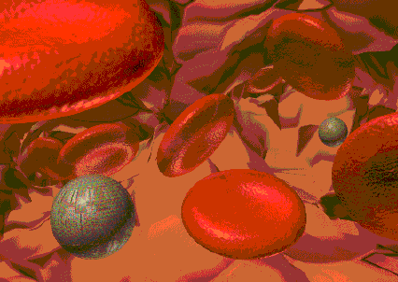
Figure 7: Respirocytes and red blood cells

Due to shortage of blood supply and risks involved in blood transfusion, research has been conducted to discover alternative pathways of substituting blood. If the outcome is successful, not only are current issues associated with blood supply would be addressed, but patients suffering from blood related diseases are also less vulnerable to life.

Basic Facts
A respirocyte is a nanotechnology that performs the same function as a red blood cell. It has useful medical applications such as treatment of anemia, respiratory diseases, general anesthesia, asphyxia, carbon monoxide poisoning, or any medical treatments involving blood transfusion. Respirocytes may also be useful in recreational applications such as increase the ability for humans to hold their breath underwater for more than 20 minutes.
By implementing a sensor on the surface, each respirocyte is able to detect the concentration of gases in the blood. This will help to determine whether oxygen binding or releasing is needed at a specific site. Respirocytes do not need power to move, as they are carried in the blood stream by blood like normal erythrocytes. They can be used for emergency respiratory functions, and may eventually serve as permanent replacement of red blood cells for individuals with anemia.
To fully mimic functions of erythrocytes, the respirocytes are designed in a way that includes sensors to determine the relative concentrations of oxygen and carbon dioxide, as well as rotors, motors, and tiny computers. Not only do they serve as universal blood substitutes, but also help to preserve living tissues via gas exchange including waste product delivery.
Red blood cells generate ATP energy via anaerobic glycolytic pathway, or the Embden-Meyerhof pathway, where two ATP molecules are generated from each molecule of glucose. Although respirocytes do not require energy to move, energy input is still necessary for rotors and to perform proper functions of the CPU. Since respirocytes do not have mitochondria and are made to be similar to red blood cells, its energy generation is also anaerobic. However, there are several different methods of obtaining energy for respirocytes. For instance, respirocytes can gain energy from radiation, consumption of readily made ATP, wireless microwave, pH gradient, concentration gradient, and as mentioned above, anaerobic conversion of glucose.

Current Design
Respirocytes are artificial red blood cells manufactured using nanotechnology. Current respirocyte designs consists of a spherical structure that ranges from 0.2 to 2 microns in diameter. A typical respirocyte has a diameter of 100 μm, and are made of sapphire or diamond. The following figures show a current respirocyte model used to transport oxygen and carbon dioxide molecules, in which are separated into two different chambers.
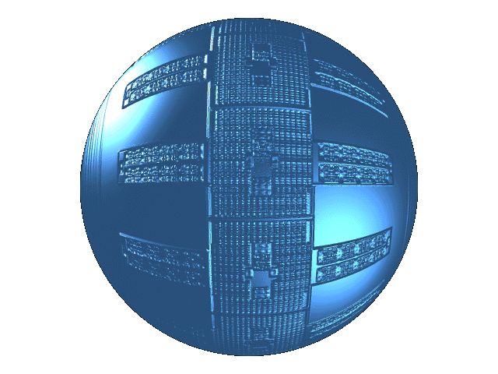
Figure 8: Spherical respirocyte

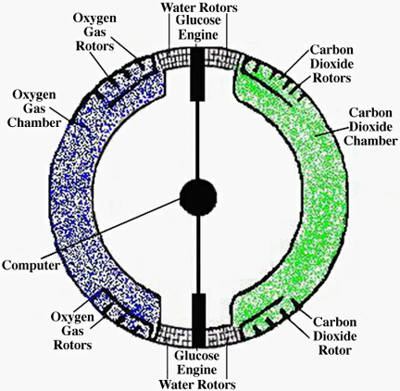
Figure 9: Respirocyte model

Table 1: List of pros and cons of current model
PROS | CONS
Universal blood | Biocompatibility
Address shortage of blood supply issues | Ethical issues
Readily available | Foreign body objection
Allows lungs to hold breaths for an extended period of time | May be damaged due to radiation damage

Current respirocytes are powered by glucose engines, which are attached to their surfaces. They exchange gases via molecular sorting rotors, which have specially shaped tips to catch a specific type of molecule, as depicted in the figure below. In the current model, each respirocyte contains three types of rotors. The first rotor captures oxygen at the lungs, the second captures carbon dioxide in tissues or in the blood stream, and the third takes in glucose from blood stream and transforms it into usable energy. The oxygen and carbon dioxide rotors are also responsible for releasing gas molecules at the appropriate locations.
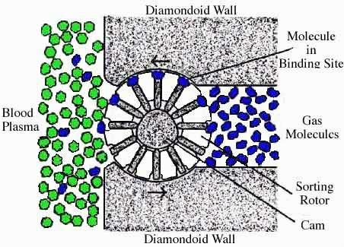
Figure 10: Sorting rotors in respirocytes

Some of the issues involved with the current design include over-heating of the device, over-pressure of gases, radiation damage, biocompatibility, interference with other blood cells, and electrical and mechanical thrombogenesis, in which clotting or cell aggregation occurs.

Design Alternatives

Proposed Design – To further improve current model
Since red blood cells depend on anaerobic conversions of glucose via the Embden-Meyerhof pathway to generate energy, it seems more efficient if a respirocyte to utilize the glucose molecules that are already present in the blood stream as its primary energy source. Therefore a glucose engine will be installed to power the device. Also, to mimic red blood cells, the shape of a respirocyte can be modeled as a flat disc chamber divided into two sections, with each of the section holding oxygen and carbon dioxide, respectively. The circumference of the disc can be constructed with a layer of semi-permeable membrane that is selective for diffusion of a specific type of gas. The center of the flat disc chamber will be a CPU, controlling all functions including the diffusion gates, which will open and close to allow diffusion through the membranes.

Table 2: Typical blood plasma concentrations of relevant molecules
Blood Gas Molecule | Concentration (molecules/m³)
O₂ (arterial) | 7.3 x 10²²
O₂ (venous) | 3.0 x 10²²
CO₂ (arterial) | 4.1 – 10.8 x 10²³
CO₂ (venous) | 4.5 – 11.4 x 10²³
H₂O (plasma) | 3.1 x 10²⁸
Glucose | 2.3 – 3.5 x 10²⁴
N₂ | 2.1 x 10²³

A disc-like structured respirocyte with 5μm diameter and a thickness of 1μm is similar to the dimensions of a red blood cell with a slightly smaller structure.

To determine the volume of gas this disc holds, the following equation can be used:
$$V={πr}^{2}h$$
$$=π{\left(2\text{.}5×{\text{10}}^{−6}\right)}^{2}×1×{\text{10}}^{−6}$$
= 1.9635 x 10⁻¹⁷ m³

To determine the total number of gas molecules this device can hold at atmospheric pressure, the ideal gas law is used, assuming body temperature to be 310K:
$$\frac{V_{1}}{T}=\frac{V_{2}}{T_{2}}$$
$$\frac{\text{22}\text{.}4L}{\text{273}K}=\frac{V_{2}}{\text{310}}$$
V₂ = 25.4 L/mol of gas

If 1 mol of O₂ occupies 25.4L at 310K,
$$\frac{1}{\text{25}\text{.}4}=\frac{X}{1\text{.}\text{9635}×{\text{10}}^{−\text{14}}L}$$
X = 7.73 x 10⁻¹⁶ mol = 465,600,000 O₂ molecules

This is assuming that the whole respirocyte is filled with oxygen only. Ideally, only half of the volume is occupied by oxygen, leaving the other half for carbon dioxide. Therefore 1 respirocyte holds 232,800,000 O₂ molecules. Compared to one drop of blood which holds 5.4 x 10¹⁴ O₂ molecules, it takes merely approximately 2.3 million respirocytes to nourish the body with enough oxygen. This shows a strong potential of respirocytes serving as replacements red blood cell functions.
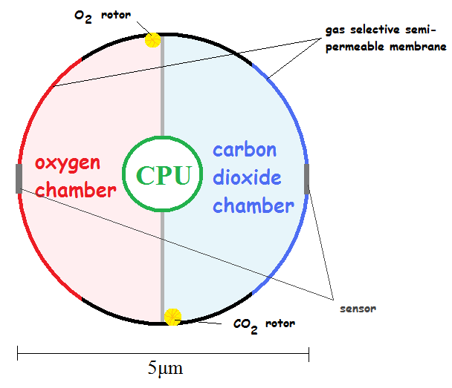
Figure 11: Top view of proposed disc-like respirocyte

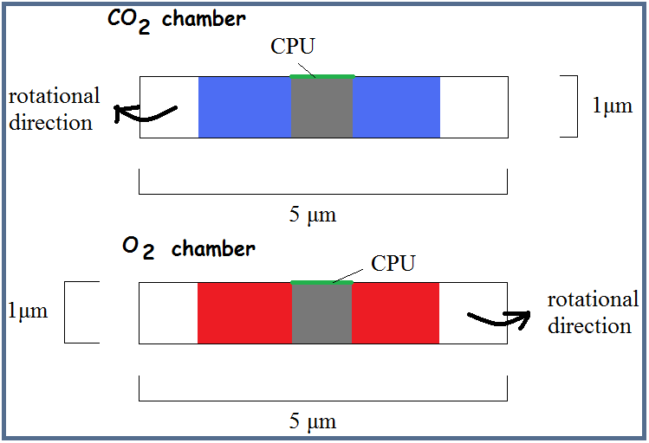
Figure 12: Side view of proposed disc-like respirocyte

By implementing a semi-permeable membrane on the disc, gases are allowed to diffuse into the chamber when the device is located in an environment with rich O₂ or CO₂. Previously proposed designs consist of rotors that continuously deposit the type of gas it senses, regardless of the amount of gas that is already in the device. This leads to accumulation of gas molecules in the respirocyte, resulting in over-pressure of the device, in which may lead to explosion and thus injuring the host. If the membrane diffusion method is implemented, the gas will stop entering the respirocyte when it is saturated. This prevents the respirocyte from over-pressuring the gas chambers, and also preserves the device without damaging the host’s body tissues.

Future Work
Despite the potentials of respirocytes in the medical field, most of the current problems still remain unsolved. Improvements can be made on implementation of the central processing unit, as well as manufacturing micro sensors. In addition, further studies are required to obtain more information on blood cell and platelet aggregation, as well as biocompatibility of these micro machines. Further research is also needed to determine ways of recycling these micro/nano robots as they reach the end of life.

Ethical Issues
With the increased oxygen and carbon dioxide delivery to the body, athletes are able to perform much better given the amount of oxygen delivered to body tissues via respirocytes. It is important to specify that the purpose of these nano/micro medical devices are to improve the quality of life of patients suffering from anemia, lung cancer, blood transfusion, organ transplants, and other diseases that causes an excessive amount of blood loss.

Conclusion
Designing respirocytes is a relatively new idea in the biomedical engineering field, thus much of the existing prototypes require further testing and data analysis. However, once the concept becomes complete, this will definitely improve clinical diagnosis in blood-related diseases, as well as medical treatments in general.
Appendices

Basic Facts
- Saturation of oxygen in artery: >94%
- Saturation of oxygen in vein: ~75%
- In the body, CO₂ exists as bicarbonate, HCO₃, which is controlled by the kidney.

Flow Chart Diagram
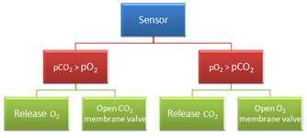
Figure 13: Flow chart diagram

CPU program – Matlab code
function [gateO2, gateCO2] = respirocyte (pO2, pCO2)
% 0 = close
% 1 = open
% pO2 = partial pressure of O2, detected by the sensor
% pCO2 = partial pressure of CO2, detected by the sensor

if pO2 > pCO2
gateO2 = 1;
gateCO2 = 0;
end

if pO2 < pCO2
gateO2 = 0;
gateCO2 = 1;
end

if gateO2 == 1
fprintf('partial pressure of O2 is greater than partial pressure of CO2');
fprintf('\t\nopen O2 gate for gas deposit, release CO2 via rotors, location: lungs\n\t');
else
fprintf('partial pressure of CO2 is greater than partial pressure of O2');
fprintf('\t\nopen CO2 gate for gas deposit, release O2 via rotors, location: tissues\n\t');
end
Acknowledgments
24675 Micro/Nano Robotics
Metin Sitti, phD., Department of Mechanical Engineering
Carnegie Mellon University, Pittsburgh, PA
References
[1] Lin, S., “Medical Nanorobot: Constructing Biological Motor Powered Nanomechanical Devices,” Science in NanoMedicine & NanoMechanics.
[2] “Nanotechnology, nanomedicine and nanosurgery,” International Journal of Surgery, 2005.
[3] Breault, K. et al., “Nanomedicine,” California Engineer, vol. 82, pp. 9-14, spring 2004.
[4] http://dev.nsta.org/evwebs/10955/page2.html
[5] El-Sayed, S. et al., “Nanobiotechnology and its applications.”
[6] http://www.nda.ox.ac.uk/wfsa/html/u10/u1003_01.htm
[7] http://www.brooksidepress.org/Products/OperationalMedicine/DATA/operationalmed/Lab/ABG_ArterialBloodGas.htm#PO2
[8] http://www.bio.davidson.edu/Courses/Molbio/MolStudents/spring2005/Heiner/hemoglobin.html
[9] Mitumoto, N. et al. “Wireless Link System for Communication and Energy Transmission of Microrobot.” Micromechanics and Human Science, pp. 57-62, 2001.
[10] Wijk, Richard and Wouter Solinge. “The energy-less red blood cell is lost: erythrocyte enzyme abnormalities of glycolysis.” Blood, Vol. 106, No. 13, pp. 4033-4042, December 2005.
[11] http://www.foresight.org/Nanomedicine/Respirocytes.html#TOC

